LEGAL NOTICE/DISCLAIMER
The information contained in this document does not establish a standard of care, nor does it constitute legal advice. The information is for general informational purposes only and is written from a risk management perspective to aid in reducing professional liability exposure. Please review this document for applicability to your specific practice. You are encouraged to consult with your personal attorney for legal advice, as specific legal requirements may vary from state to state.

Note: This authorization is to be reviewed with the patient and signed by the patient PRIOR to the date of surgery, at a surgical consult or pre-surgery visit. It should not be reviewed for the first time and signed on the day of surgery.
Consent for Surgery

Patient: __________________________________ Date of Birth:____________________________

You have the right and responsibility to make decisions about your health care. Your doctor can give you information and advice, BUT IT IS YOUR DECISION WHETHER OR NOT TO HAVE SURGERY OR TREATMENT.

- I give my permission to Dr. _________________________ to perform the following operation/procedure/treatment on me: ____________________________________________________________________________________________________
____________________________________________________ _____________________________________________
Site/Location Side
The purpose of the operation or procedure is to: _____________________________________________________________
____________________________________________________________________________________________________

- I understand that the potential benefits and outcomes of the operation/procedure/treatment include, but are not limited to:
____________________________________________________________________________________________________
____________________________________________________________________________________________________
____________________________________________________________________________________________________

- I understand that the potential risks and complications of the surgery/procedure/treatment include, but are not limited to [check only those that apply]:
 | Infection |  | Allergic reaction to suture or other implanted materials
 | Redness and/or swelling of operated areas |  | Damage to blood supply/circulation (such as blood clots)
 | Poor healing of incisions and/or bones |  | Damage to nerves (burning, tingling, stinging, numbness)
 | Failure of the incisions and/or bones to heal |  | Loss of implant through degeneration/breakdown
 | Excessive bleeding |  | Loss of toe, foot, limb or life
 | Operation/procedure/treatment may not work |  | Permanent swelling/enlargement of toe, foot or leg
 | Condition or pain may come back |  | Paralysis/paraplegia/quadriplegia
 | Condition/disability may get worse |  | Brain damage
 | Bad or allergic reaction to anesthesia |  | More treatment or surgery may be needed
 | Painful or large scars |  | Significant or permanent pain (such as CRPS)
 | Calluses or sores may develop on the foot |  | Stroke/heart attack/death
 | Fracture/break or dislocation of a bone |  | Other: ____________________________________
 | Swollen toe/stiff toe/shorter toe/lifted toe |  | Other: ____________________________________
 | Difficulty in walking/wearing shoes/playing sports |  | Other: ____________________________________

- My doctor has discussed other options to this surgery/procedure/treatment for my condition with me. These include but are not limited to [check only those that apply]:
 | Wide shoes or change in shoe gear |  |  | Orthotic shoe inserts |  |  | No treatment at all
 | Periodic care |  |  | Change in job |  |  | Other: _____________________
 | Antibiotics |  |  | Injections |  |  | Other: _____________________
 | Padding and strapping |  |  | Physical therapy |  |  | Other: _____________________

- Serial Procedures – I understand that I will receive a series of the same treatments over a time period not to exceed ____ days. From ___/___/___ to ___/___/___. N/A _______________

- I understand that other health care providers such as surgical assistants, physician assistants, nurses, and other surgical staff may assist the doctor named above in performing my surgery. A surgical resident(s) may participate in some or all of the surgery. I give my permission for them to do so.

- I consent to the use of anesthesia, except for ________________ ______________________.

- I consent to the taking of x-rays; blood samples and/or urine samples for laboratory testing; and other tests that may be necessary.

- I consent to the use and transfusion of blood and blood products if my doctor feels it is necessary. I understand that my doctor will not be responsible for any bad reactions as a result of a transfusion.

- I consent to the disposal of any tissues or parts which may be taken out during the procedure.

- I have told my doctor about all my allergies. (LIST ALLERGIES) ________________________________________________
____________________________________________________________________________________________________

- I have told my doctor:
  - About all of the drugs I take, including prescription and over-the-counter medications, herbal products, nutritional supplements, and recreational drugs;
  - About all of my medical conditions such as allergies, pregnancy, epilepsy, herpes, HIV/AIDS, diabetes, circulation problems, etc. that I am aware of;
  - If I smoke;
  - If I use alcohol .
I will accept full responsibility for any problems with my treatment that may result because of my failure or refusal to tell my doctor about these things.

- I understand that no guarantees or promises have been made to me about the results of this operation/procedure/treatment.

- I understand that sometimes during surgery, it is discovered that additional surgery may be needed. I give my doctor permission to do additional surgery if he/she feels it is necessary.

I certify that I have read, or had the form read and explained to me, and that I fully understand its contents. I have been given ample opportunity to ask questions. My questions have been answered to my satisfaction. All blanks or statements that required completion were completed before I signed this form. I drew a line through all statements that I do not approve before I signed this form.

I understand the risks, benefits, and alternatives to the proposed operation, procedure, or treatment. I consent to the operation, procedure, or treatment to be performed. YES ______ NO ______

_______________________________________ ____________________________________
Signature of patient Date/Time

________________________________________ ____________________________________
Witness Date/Time

The patient is unable to consent because: ______________________________________________________________________
Therefore I consent for the patient.

________________________________________ ______________________________________
Legal Representative of the patient Date/Time

____________________________________________
Relationship

I declare that I have personally explained the above information to the patient or the patient’s legal representative.

_____________________________________________ ___________________________________________
Physician Date/Time

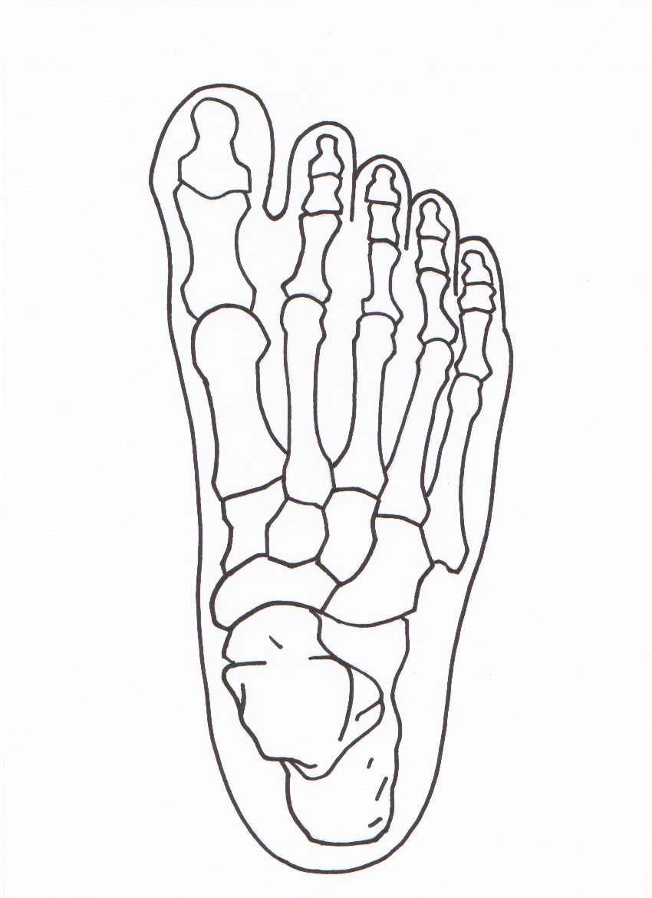
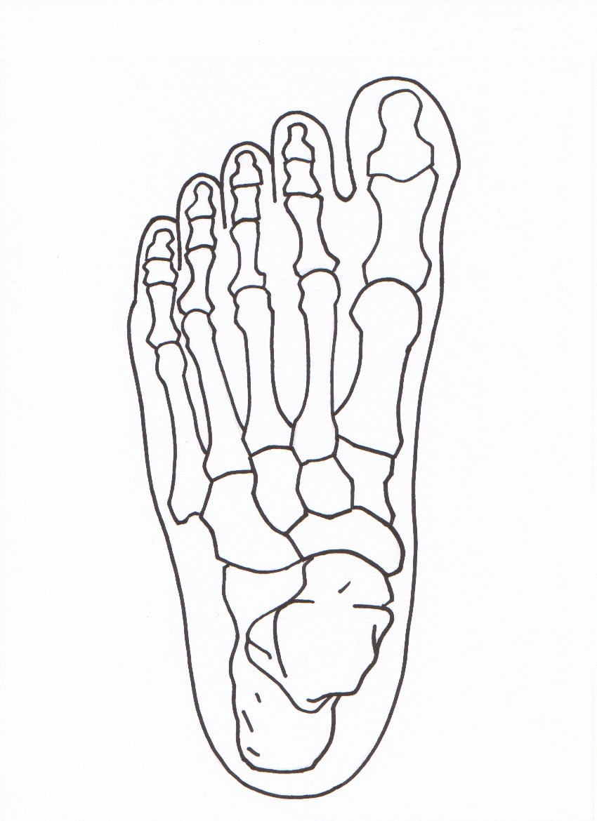
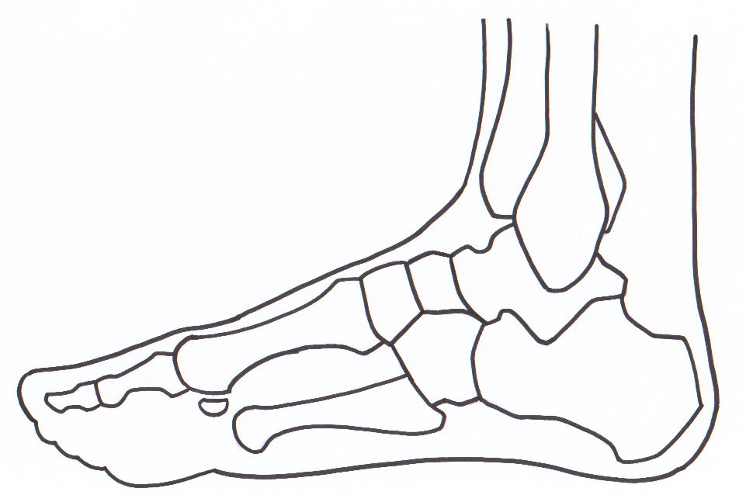
Legend: Bones to be cut and/or removed or moved
These diagrams were explained to me and I understand them.

Patient or Legal Representative Signature: _________________________________________ Date: _____________

Witness Signature: ____________________________________________________________ Date: _____________
LEFT
RIGHT

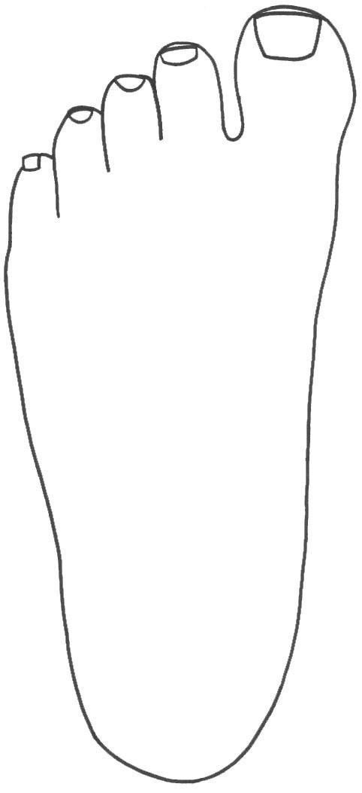
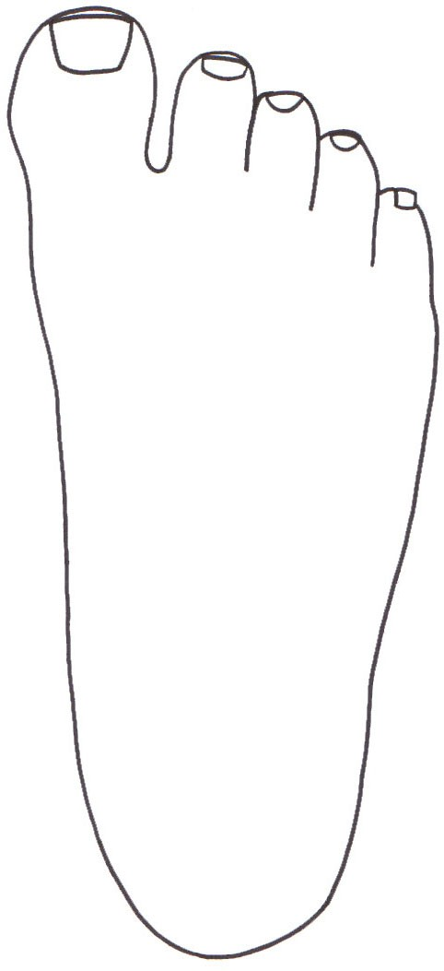
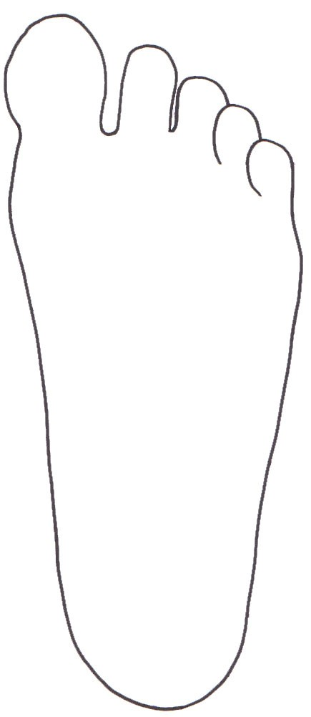
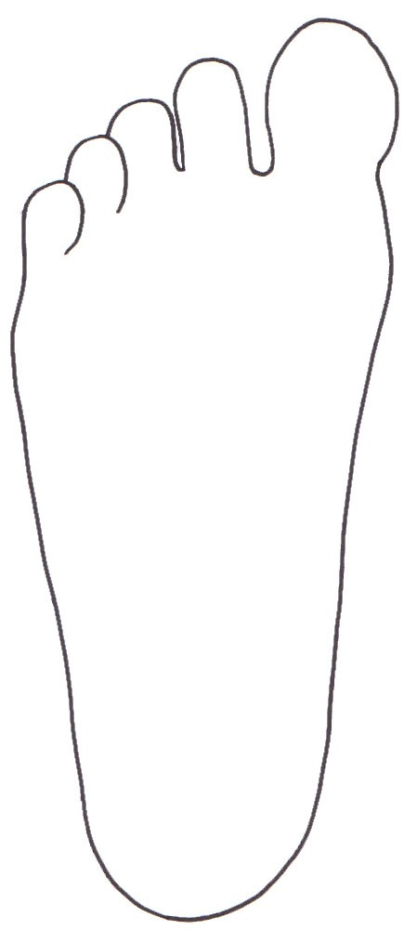
Left Foot (top)

Right Foot (top)
Left Foot (bottom)

Right Foot (bottom)
Legend: Area(s) to be cut and/or removed.
These diagrams were explained to me and I understand them.

Patient or Legal Representative Signature: _________________________________________ Date: _____________

Witness Signature: ____________________________________________________________ Date: _____________

Legend: Bones to be cut and/or removed or moved

These diagrams were explained to me and I understand them.

Patient or Legal Representative Signature: _________________________________________ Date: _____________

Witness Signature: ____________________________________________________________ Date: _____________

Legend: Bones to be cut and/or removed or moved

These diagrams were explained to me and I understand them.

Patient or Legal Representative Signature: _________________________________________ Date: _____________

Witness Signature: ____________________________________________________________ Date: _____________

These diagrams were explained to me and I understand them.

Patient or Legal Representative Signature: _________________________________________ Date: _____________

Witness Signature: ____________________________________________________________ Date: _____________

Legend: Bones to be cut and/or removed or moved

Legend: Bones to be cut and/or removed or moved

These diagrams were explained to me and I understand them.

Patient or Legal Representative Signature: _________________________________________ Date: _____________

Witness Signature: ____________________________________________________________ Date: _____________

Legend: Bones to be cut and/or removed or moved

These diagrams were explained to me and I understand them.

Patient or Legal Representative Signature: _________________________________________ Date: _____________

Witness Signature: ____________________________________________________________ Date: _____________

Legend: Area(s) to be cut and/or removed or moved

These diagrams were explained to me and I understand them.

Patient or Legal Representative Signature: _________________________________________ Date: _____________

Witness Signature: ____________________________________________________________ Date: _____________

Legend: Area to be cut and/or removed or moved

These diagrams were explained to me and I understand them.

Patient or Legal Representative Signature: _________________________________________ Date: _____________

Witness Signature: ____________________________________________________________ Date: _____________

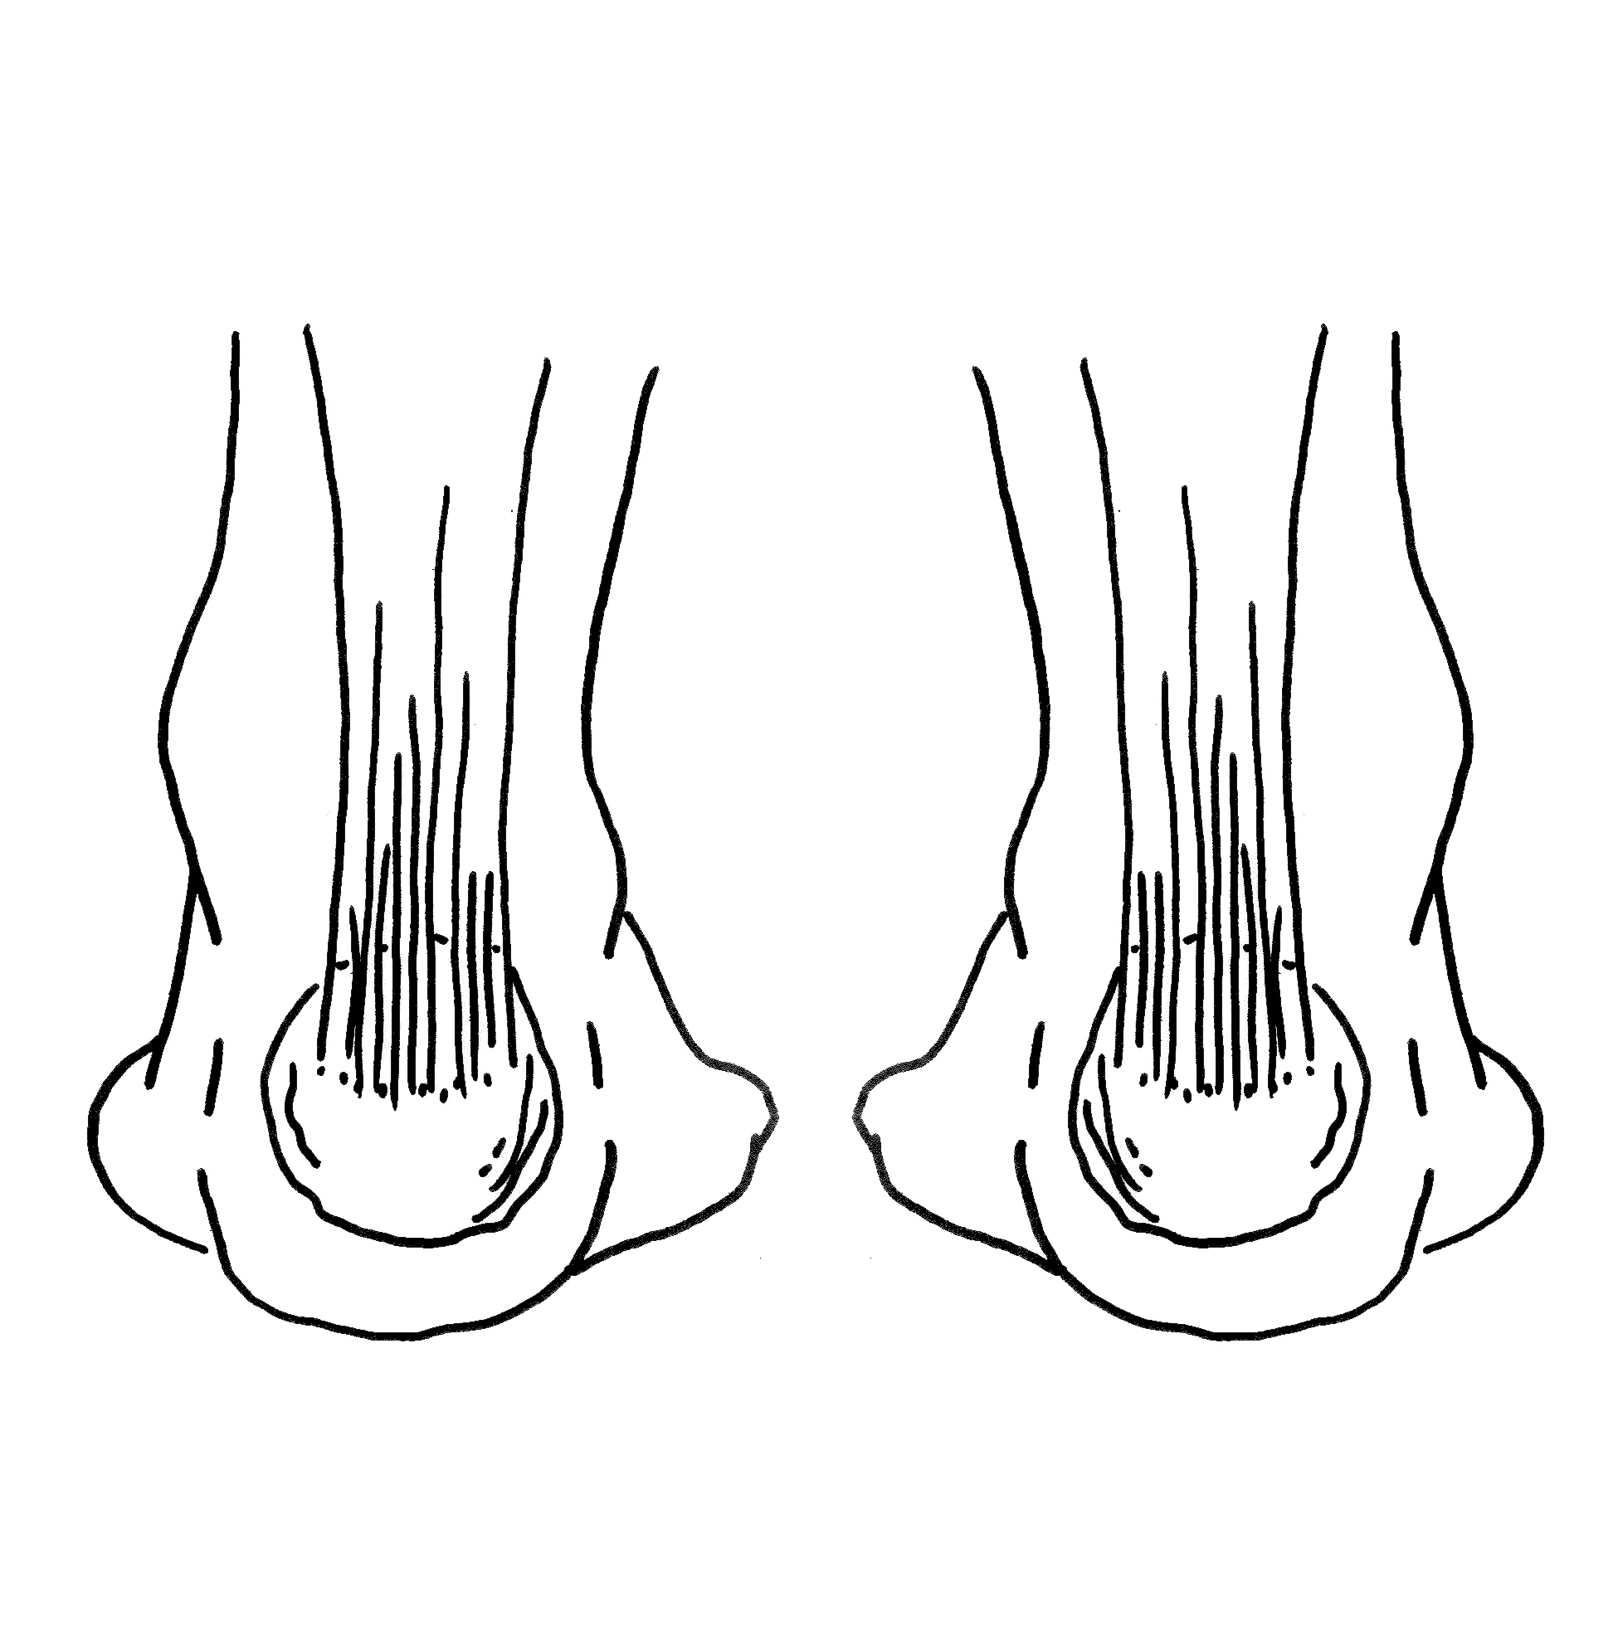

Legend: Area to be cut and/or removed or moved

These diagrams were explained to me and I understand them.

Patient or Legal Representative Signature: _________________________________________ Date: _____________

Witness Signature: ____________________________________________________________ Date: _____________

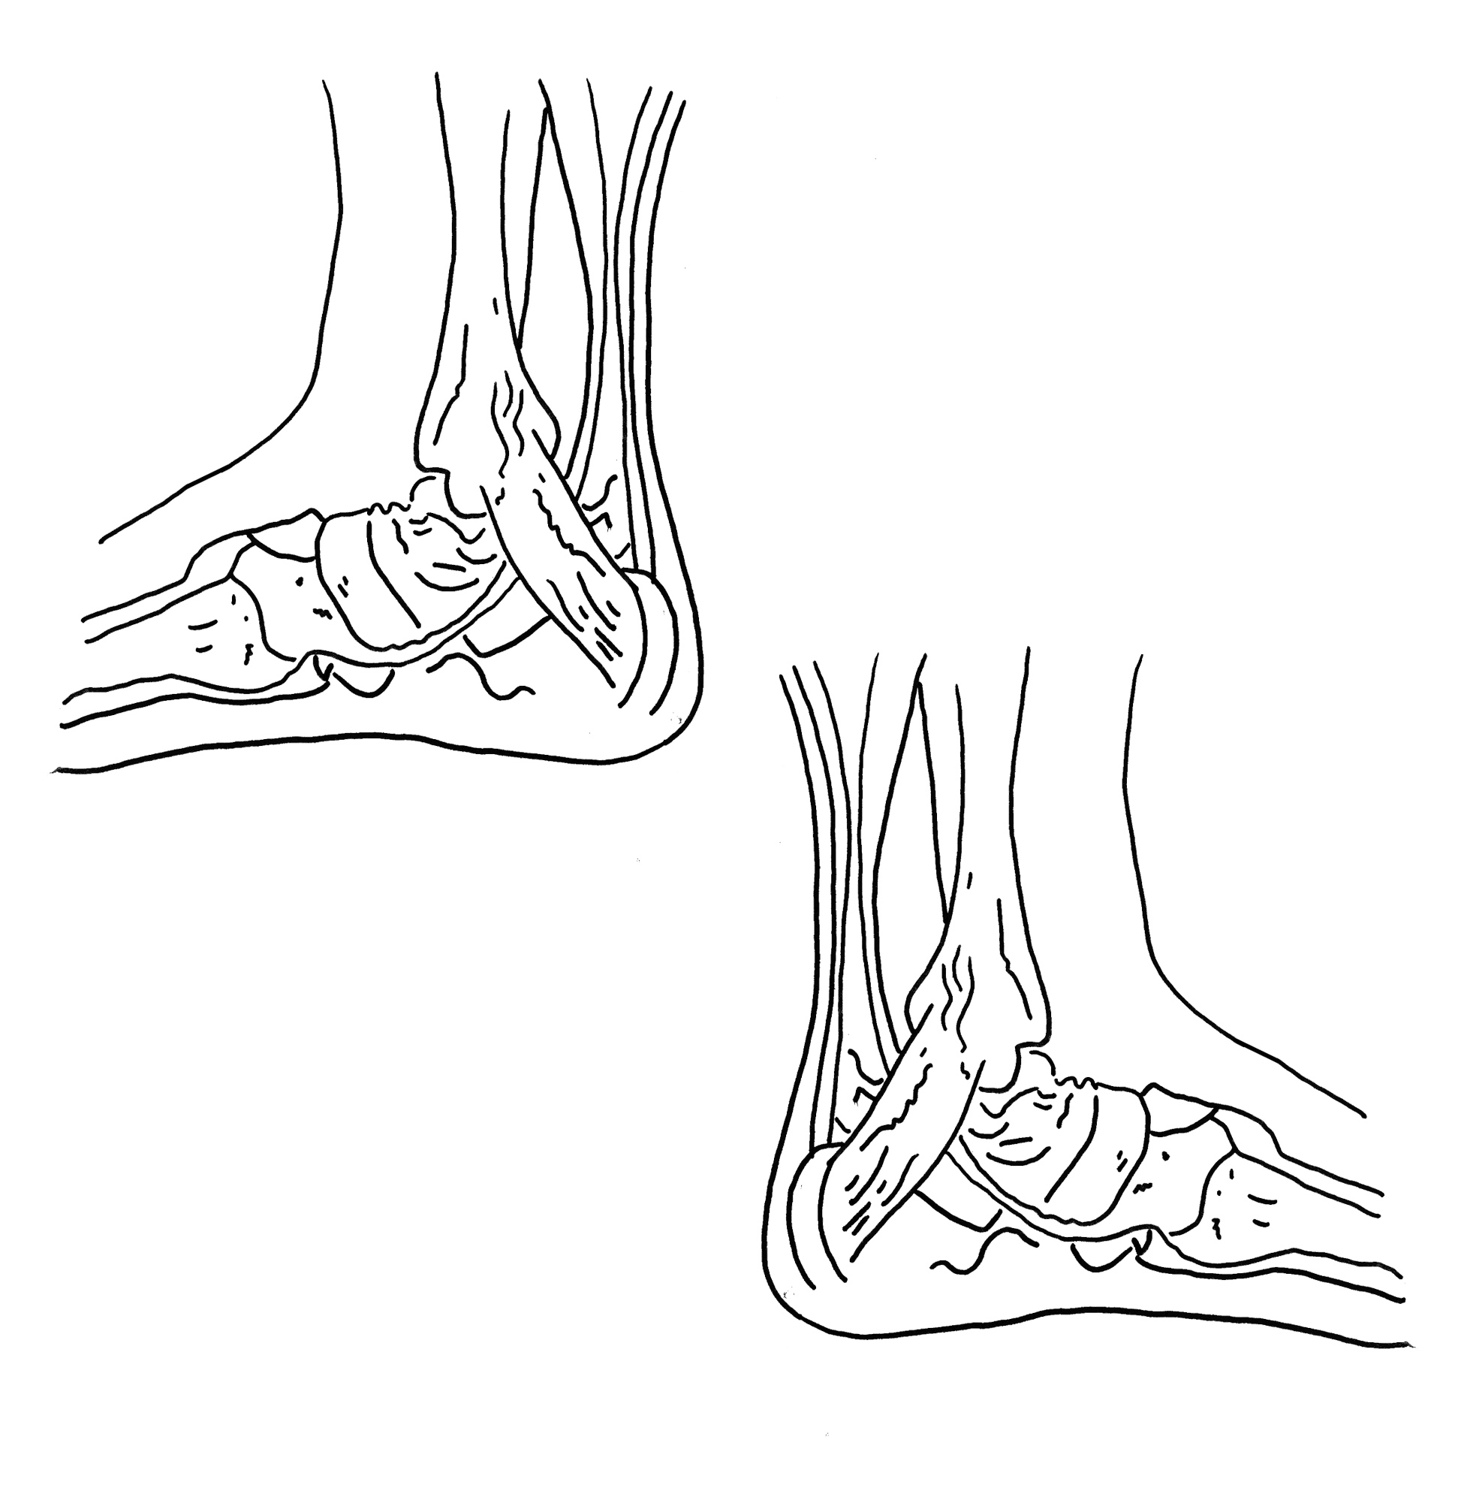

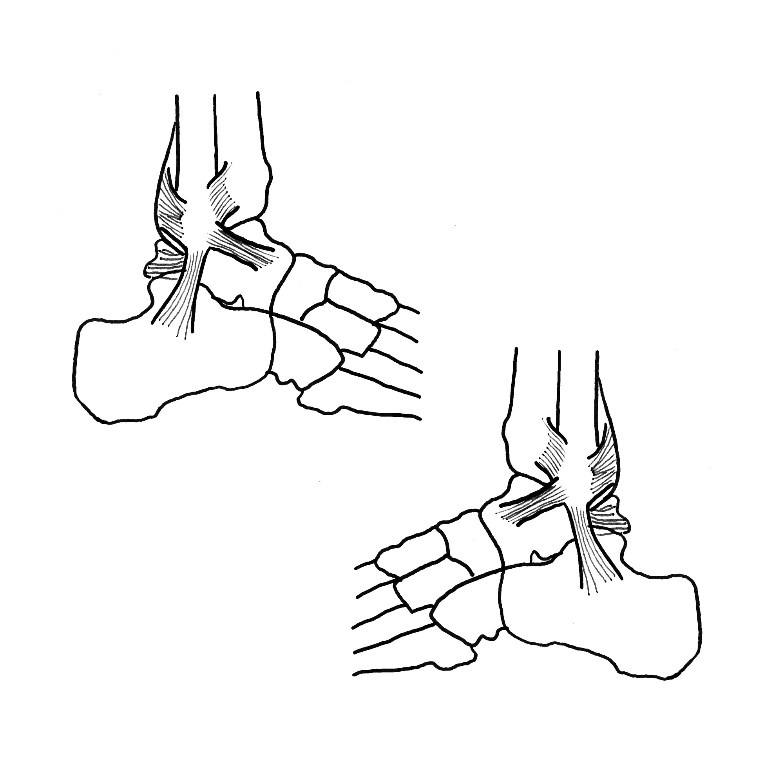
Legend: Area to be cut and/or removed or moved

These diagrams were explained to me and I understand them.

Patient or Legal Representative Signature: _________________________________________ Date: _____________

Witness Signature: ____________________________________________________________ Date: _____________

Legend: Area to be cut and/or removed or moved

These diagrams were explained to me and I understand them.

Patient or Legal Representative Signature: _________________________________________ Date: _____________

Witness Signature: ____________________________________________________________ Date: _____________

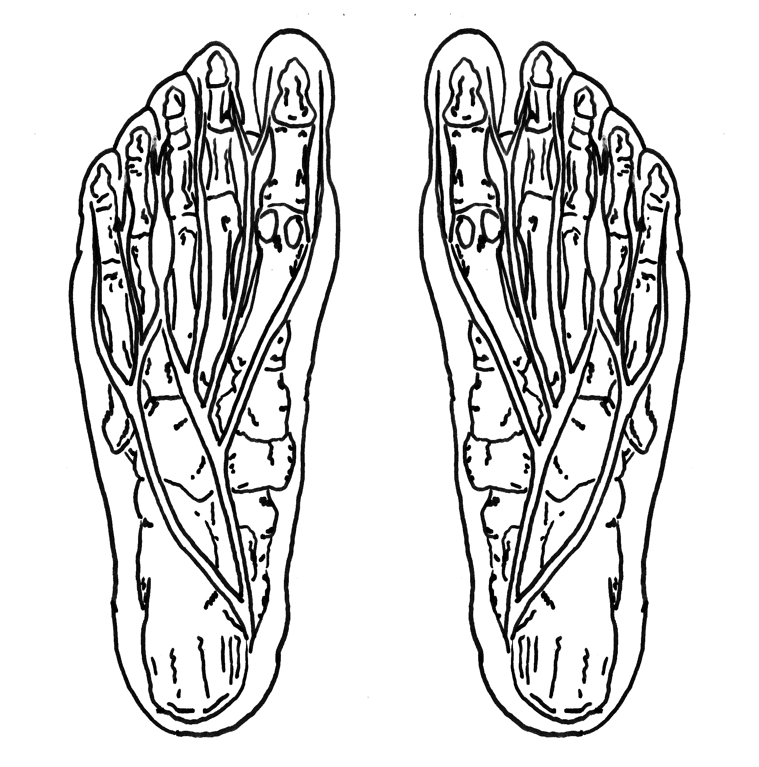

Legend: Area to be cut and/or removed or moved

These diagrams were explained to me and I understand them.

Patient or Legal Representative Signature: _________________________________________ Date: _____________

Witness Signature: ____________________________________________________________ Date: _____________

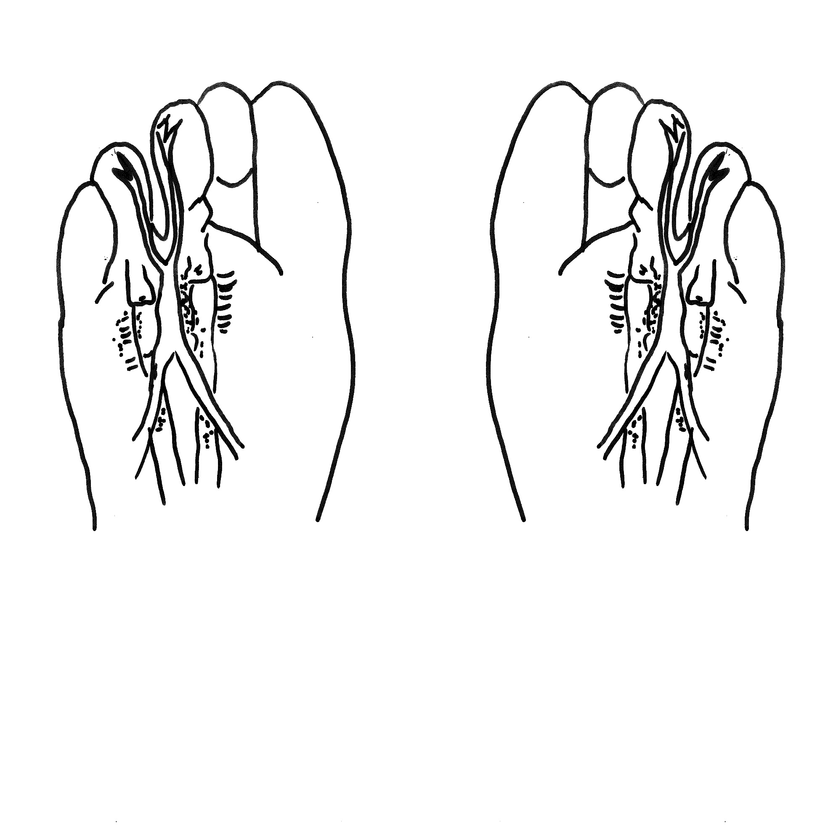

These diagrams were explained to me and I understand them.

Patient or Legal Representative Signature: _________________________________________ Date: _____________

Witness Signature: ____________________________________________________________ Date: _____________

Legend: Bones to be cut and/or removed or moved

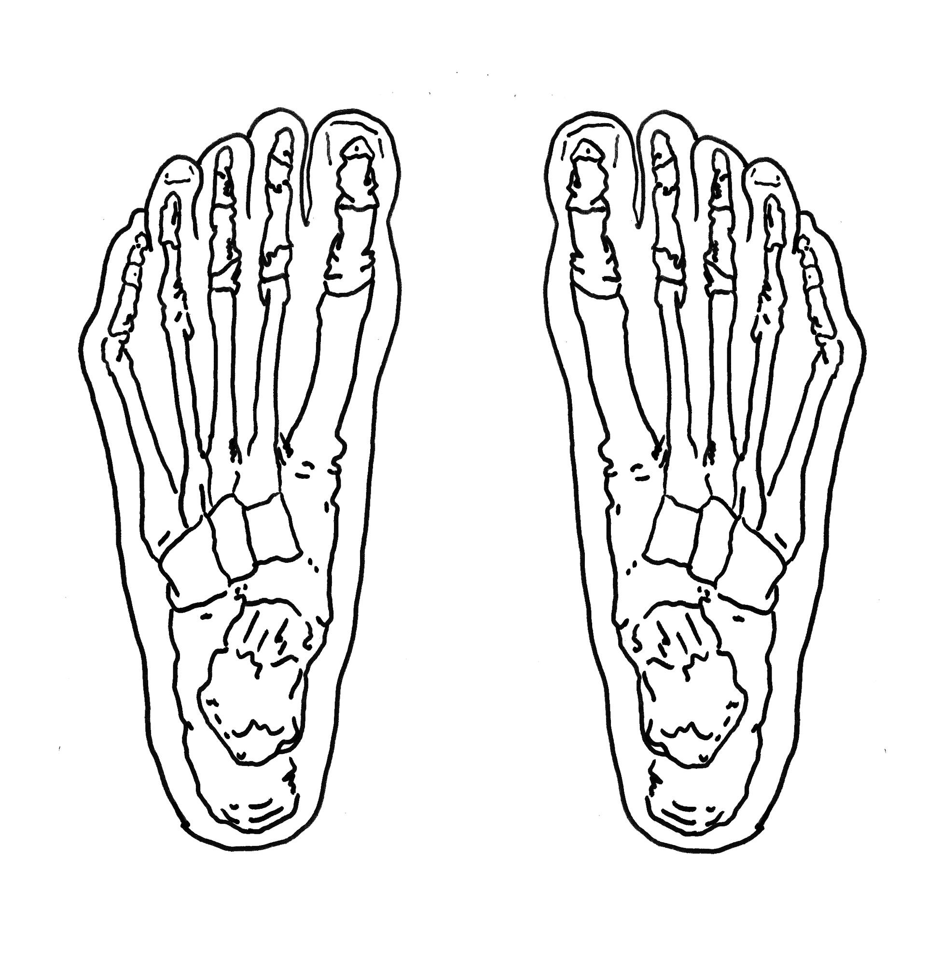

Legend: Area to be cut and/or removed or moved

These diagrams were explained to me and I understand them.

Patient or Legal Representative Signature: _________________________________________ Date: _____________

Witness Signature: ____________________________________________________________ Date: _____________

